JR ACRY LENTEN PROJECT COMPLETED

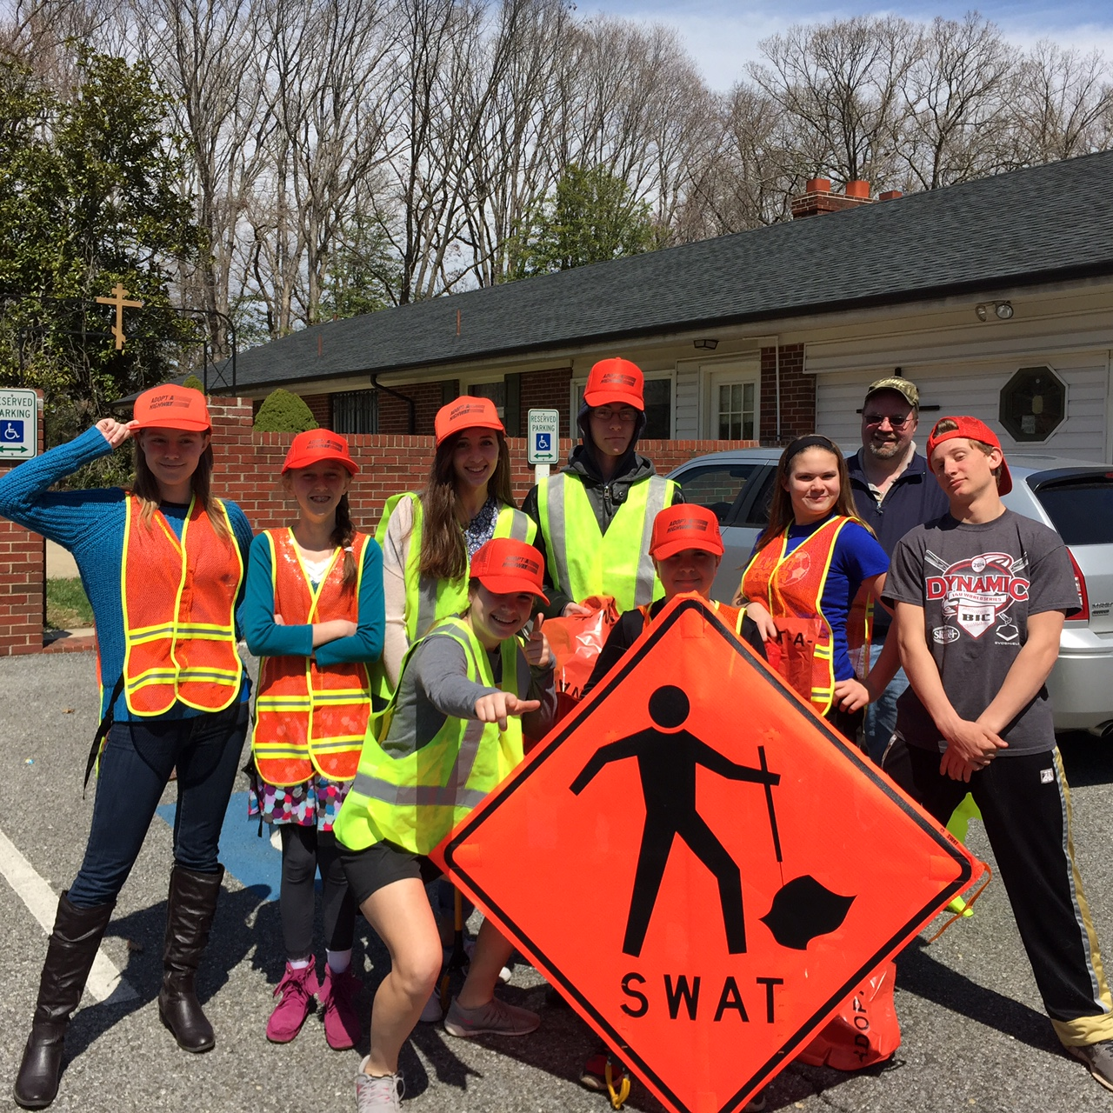
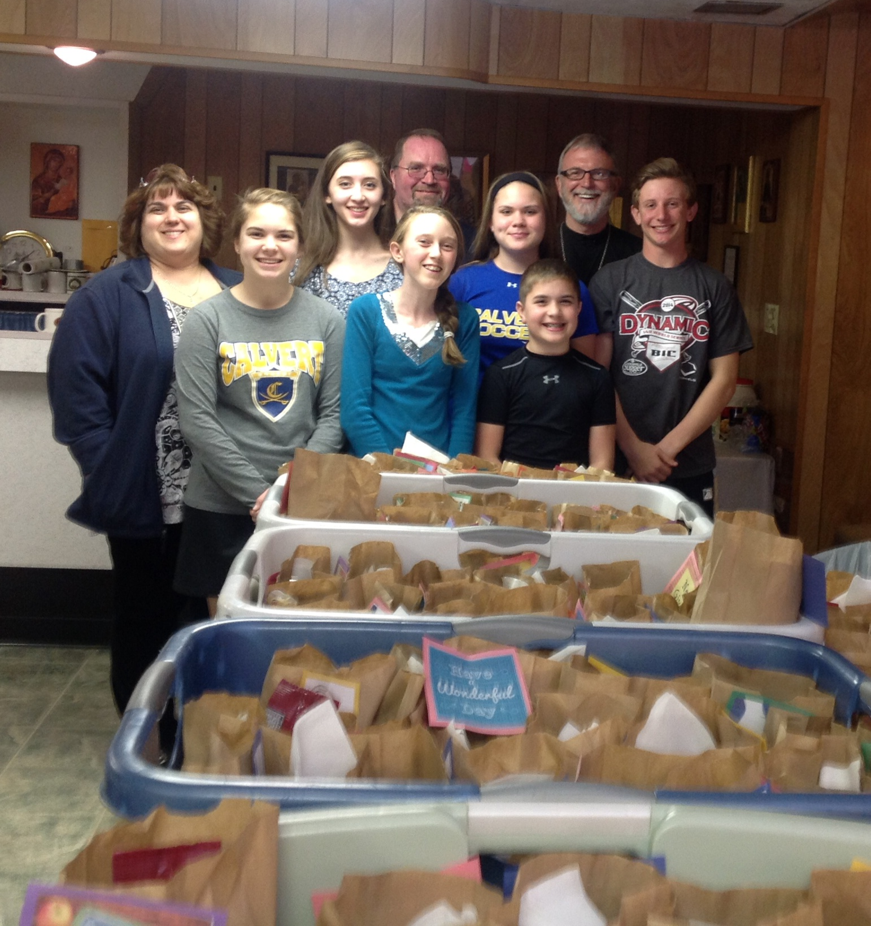
On April 5th, it was a very eventful day for the Jr. ACRY. We took on a full day of opportunities. After liturgy, the Jr. ACRY picked up trash along our new boundary for Road Clean-Up. After many interesting finds, including a brand new house phone and a deer carcass, we headed back down to the church basement to assemble lunch bags for the homeless. This year we managed a total of (151) lunch bags compared to last years total of (87). After all lunches were completed and loaded into the truck, we ALL attended confession and headed over to Good Sheppard Church. There, we set up cots; tables, prepared, served, and cleaned up from dinner, played with the kids by reading, playing games, and providing an Easter egg hunt. Once again, this was a very successful project to be apart of. It gives each and everyone of us an amazing feeling, knowing that we can slowly change one life at a time, if even for a day. A collage of pictures from our day will be displayed in the social area for everyone to see.
Our Road Clean Up Crew
(151) Lunch Bags Completed
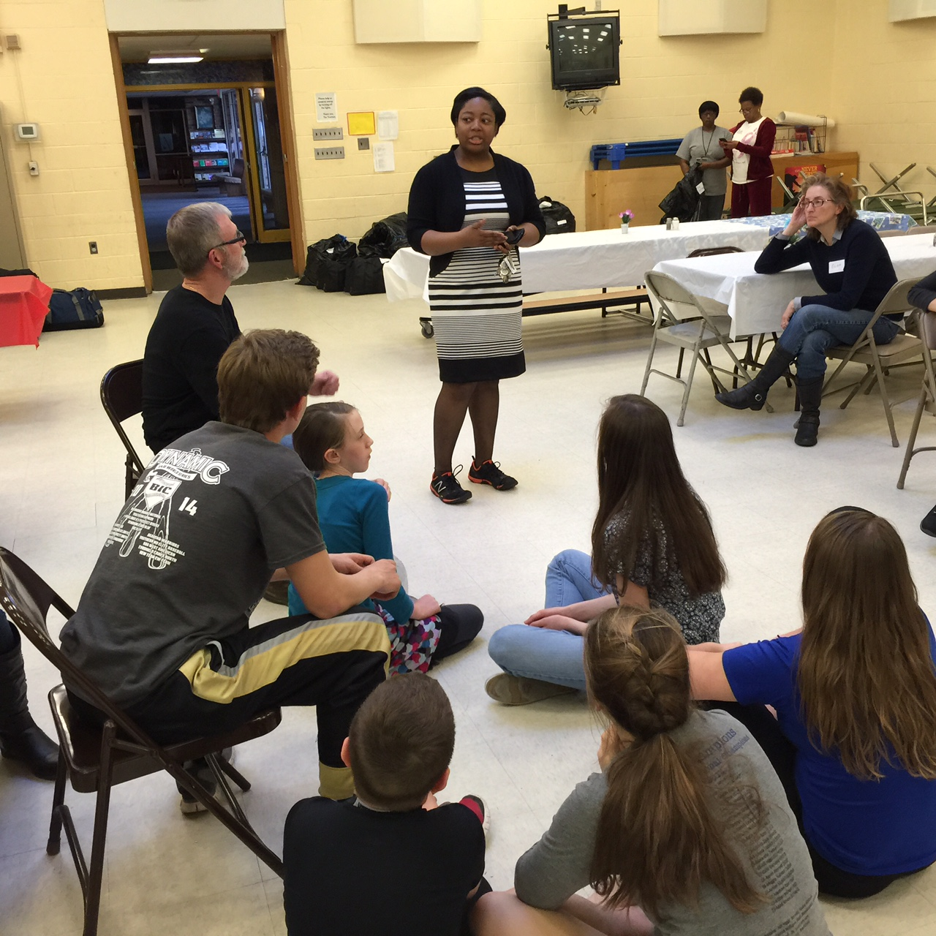
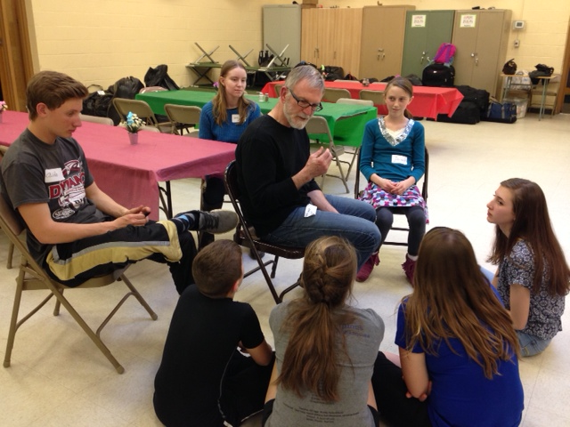
The Jr. ACRY would like to send a thank you to everyone who made this possible with donations and support.
Father giving us a pep talk
Corae Young (Asst Director) explaining the many programs Life Styles of MD has to offer and the process of the Safe Night Program.

